D

e p l o y

t h e

r i g h t

t

y p e

o f

c l o u d

t o

a c c

e l e r a t e

i n n o v a t i o n

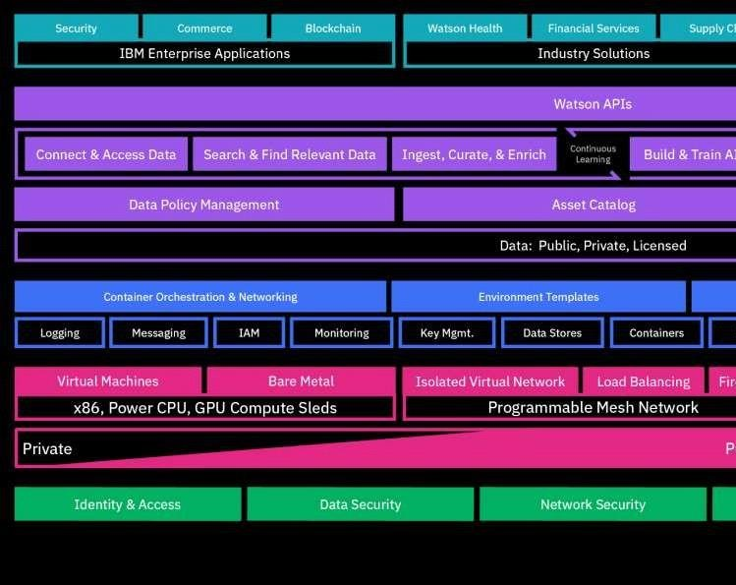

IBM CLOUD ARCHITECTURE

# Cloud forBusiness

IBM provides tools to help clients manage multi-cloud environments

By 2020, more than 90% of enterprises will use multiple cloud services and platforms1

IBM Cloud

|  |  |  |  |  |  |
| --- | --- | --- | --- | --- | --- |
|  |  |  |  |  |  |

|  |  |  |  |  |  |
| --- | --- | --- | --- | --- | --- |
|  |  |  |  |  |  |

n o

o g

W

M

&

|  |  |  |  |  |  |  |
| --- | --- | --- | --- | --- | --- | --- |
| Cloud Integration | | Cognitive Micro-services | | | DevOps Tooling | |
|  | | | | | | |
| Network ing | Secu rity | En Coreise  Infr terpr | Cogn itive Syst ems | Vir tua l Ser  ver s | Obj ect Stor age | File Stora ge |
|  |  | ture |  |  |  |  |
|  |  | as tr u  c |  |  |  |  |

|  |  |  |  |  |  |  |  |  |  |
| --- | --- | --- | --- | --- | --- | --- | --- | --- | --- |
| c l  y | a t s o n  C  y b e r  S  e c u r i t y | t r | I | t  i r t  l  t | l  i | I B  R  i s k  C  o |  |  |  |
| A  s s e t M  g m  t. | | |
| i | | |

|  |  |  |  |  |  |  |  |
| --- | --- | --- | --- | --- | --- | --- | --- |
|  |  |  |  |  |  | p li a n c  e |  |

m

MATCHING THE RIGHT CLOUD TO THE RIGHT

WORKLOEAntDerprise transformation

required for cloud adoption

PERFORMANCE & CONTROL

PORTABILITY

DEVELOPMENT SPEED

* **Open Kubernetes-basedcontainer platform**
* **Cloud Foundry for app devand deployment**
* **DevOps toolchain integration**
* **Integration capabilities tounlock and connect**
* **Secure access to**

public cloud services (AI, Blockchain)

* **Consistent experienceacross private/public**

•

* **Containerized versions ofIBM Middleware**
* **Prescriptive guidance tooptimize workloads**
* **Work with existing apps, data, skills, infrastructure**
* **Core operational servicesincluding logging, monitoring, security**
* **Flexibility to integrate withexisting tools and processes**

# Cloud forBusiness.